**SOLANO COMMUNITY COLLEGE**

**MT 162, ROBOTICS**

Fall, 2018

SOLANO COMMUNITY COLLEGE

ROBOTIC SYSTEMS MT-162

**LAB 8: PAYLOADS**

**Catharine Crayne**

11/7/18

**OBJECTIVE**:

1. To learn how to create motion program that use various methods and types of branching.

**GROUP MEMBERS**

*Dianne*

**MATERIALS**: RoboGuide and Laptop, Fanuc Robot, Box

**PROCEDURE**:

1. Power up the robot controller. Place the robot and pendant in Teach Mode.
2. Create a new program called “Lab8_MAINYourName”.
3. Use an incrementing Data Register with IF/CALL branching so that your program will automatically execute your circle, box, triangle programs for three cycles and then stop.
4. Test it in STEP and RUN modes.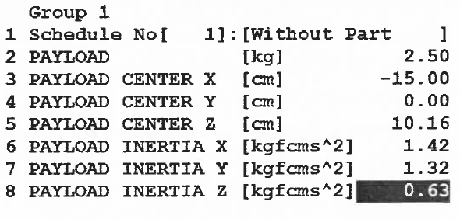
5. Directly enter data into payload schedules 1, 2, and 3 ([MENUS] → SYSTEM → TYPE → MOTION) as shown to the right.
6. Now edit your Lab8_MAIN program so that your program switches between payloads with each cycle. So Payload 1 is set for the first cycle, Payload 2 for the second cycle, Payload 3 for the third cycle.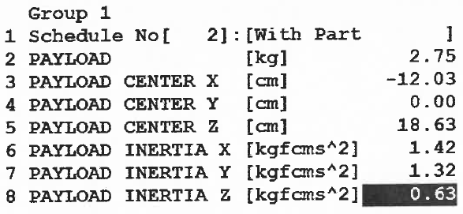
7. Test and verify its operation.
8. Export your program to a text file.

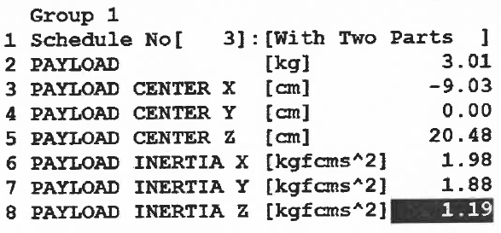

**RESULTS - DATA**

Not applicable for this lab

**OBSERVATIONS**

Step 2 - 4

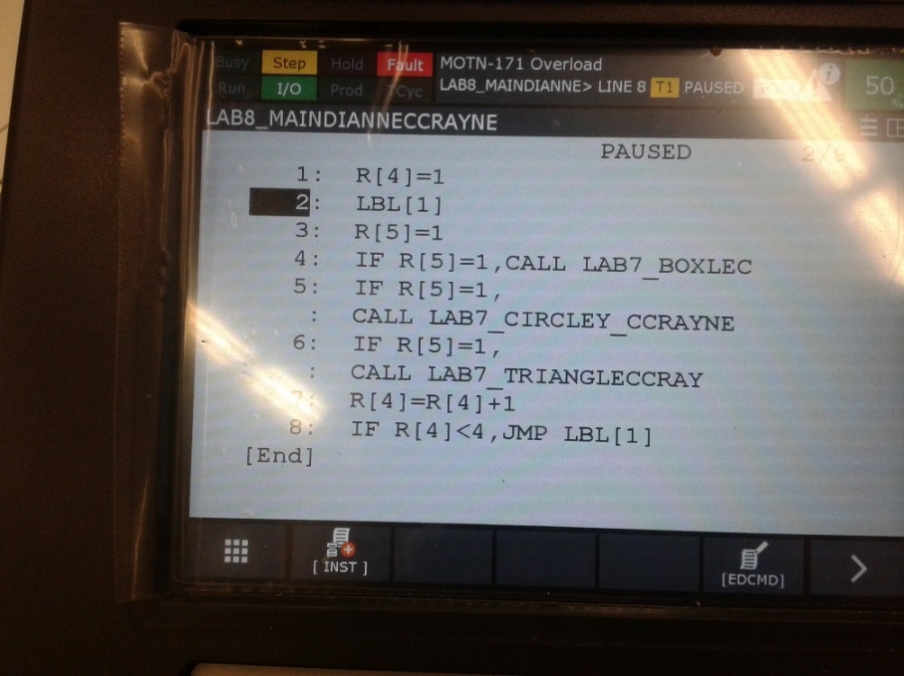

Step 5

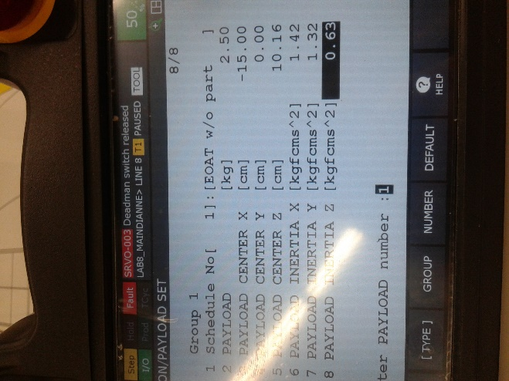 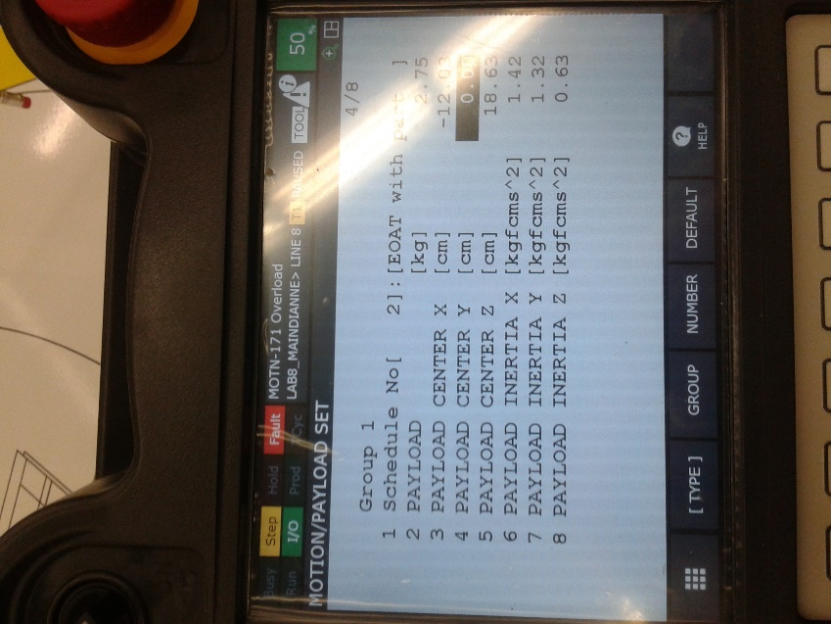 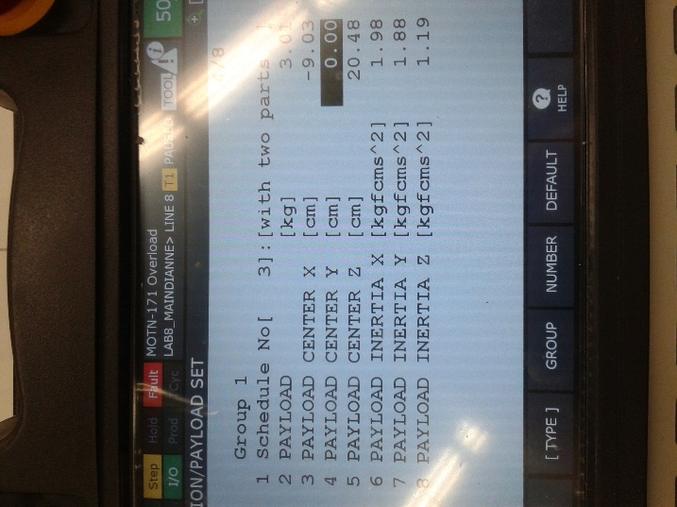

Step 6 – 7

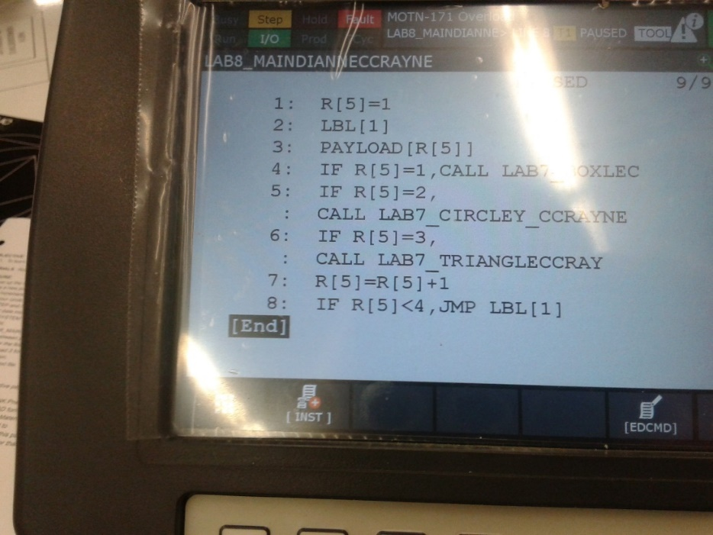

**Analysis Questions:**

1. Why is it necessary to set the active payload for these robots?

*It is necessary to set accurate active payload values because they are critical for proper function of Collision Guard, repeatability, path and accuracy. It also increases efficiency (cycle time), safety and longevity of the robot gearing.*

1. Download the CAD file for a SCHUNK Pneumatic Gripper RH 907. Use the Inventor CAD format and load it into Fusion 360. In the Physical Materials section of the Model, change the material to Aluminum. Then display the Properties of this part. Write down the values for the Payload data for that Gripper.

